Welcome to
Springvalley Middle School
2025-2026

The Springvalley Middle School vision is to connect with students in a caring environment that enables them
Develop their Curiosity, Creativity and Connection

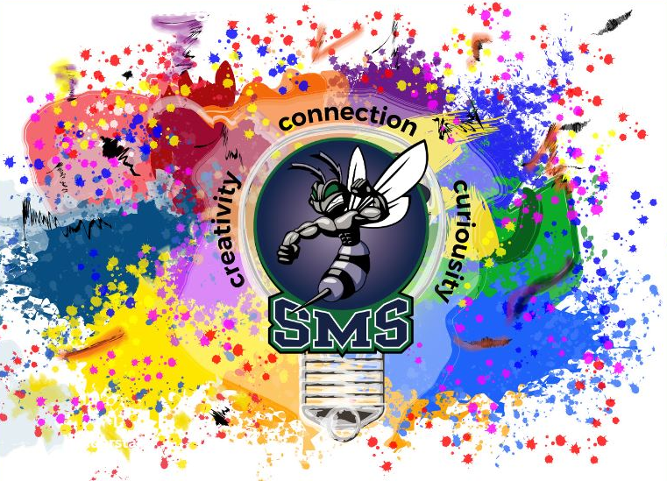

Parent and Student
Information & Handbook

Welcome to SMS

Principal: Mr. T. Gruenenwald
Vice Principal: Ms. J. Ramsey
Head Secretary: Mrs. K. Macaulay
Records Clerk: Ms. Boast
Receptionist: Ms. D. Day

Population:
For September 2025
Students: 585 Teachers: 44
Support Staff: 39 Grades 6,7,8

Facilities:

Classrooms - 25 including
- An open forum for student gatherings and games
- 7 portables

Applied Skills:
- Wood Shop, Metal Shop, Foods and Sewing, Crafts and Cooking, Electronics, Robotics

Fine Arts:
- Art, Music, Drama, Video Production, Yearbook.

LLC:
- Includes a full-time teacher-librarian and clerk
- Technology-based resources

Gymnasium:
- A full-size gym with mezzanine, weight facility and bleachers.

Sports Teams
- Basketball, Volleyball, Rugby, Archery, Track and Field, Cross Country Running, Ultimate Frisbee, Multi-Sport Intramurals

Grounds:
- Includes basketball courts, large, newly sodded playing fields

Support Services:
- Includes Counselling, Learning Assistance, Indigenous Advocacy and Tutoring, Homework Club, Career Programs, Certified Education Assistants (CEA), Parent Advisory Council.

Core Values of the Middle School

School District 23 is committed to supporting middle school philosophy. For a school to be successful, students, staff and parents must be committed to a clearly defined set of core values. These values provide direction for school programs and the establishment of a school climate in which each student may have the opportunity to grow as an individual and reach an optimum level of academic, artistic, athletic, and personal success. The middle school concept has its own unique set of core values. SMS supports the core values characterized by all developmentally responsive middle schools. The Middle Years Association of BC, a chapter of the National Middle School Association, supports the belief that:

Developmentally Responsive Middle Schools are characterized by:

Educators committed to young adolescents
A shared vision
High expectations for all
An adult advocate for every child
Family and community partnerships
A positive school climate

Therefore, Developmentally Responsive Middle Schools provide:

Curriculum that is challenging, integrative and exploratory
Varied teaching and learning approaches
Assessment and evaluation that promote learning
Flexible organizational structures
Programs and policies that foster health, wellness and safety
Comprehensive guidance and support services

FLEXIBLE SCHEDULING

At SMS we have a flexible schedule that allows us to incorporate effective practices for the middle year's learner. Highlights of our schedule are included below:

CARING COMMUNITIES: Students participate in a "Caring Communities" block every morning where the main focus is to build connections and create community. We develop weekly/monthly school wide theme which are mainly SEL based. This is our version of a homeroom for students!

ENRICHMENT: In keeping with the middle school concept of exploratory programs, our staff has initiated and organized Enrichment opportunities: three sessions per year, each ten weeks long. Students select an Enrichment experience to enhance their knowledge and skill acquisition. Some of our community partners (YMCA, B&G Club) also provide enrichment opportunities during this block.

TEAMING: In keeping with the core values of middle schools, our staff supports the concept of teaming, there are core teams of teachers for all grades, along with elective teams and our school-based team of support staff.

SCHOOL SUPPLIES

Please check our website (Documents and Publications) for an up-to-date, grade-specific supplies list. We update this yearly.

SCHOOL FEES

A CULTURAL AND ACTIVITY FEE of $30.00 covers the cost of the cultural assembly program which is offered at each school and includes the cost of lock rentals, and student equipment/activity needs.

MUSIC/BAND: Instrument rental/cleaning fee – please discuss this with Ms. Angle. This may be an out-of-the-schedule program (before and after school).

All fees may be paid on-line at sms.sd23.bc.ca and click on the 'School Cash Online' button and follow the instructions for payment.

BUS PASSES

If you require School District bus transportation, please go to sd23.bc.ca and click on the 'School Bus Transportation' link. Under Programs and Services, you will notice on the left hand side of the page 'School Bus Transportation' Routes, Eligibility, Payments, Apply etc. In the interests of student safety, effective spring of 2024, students are required to scan their bus pass as they enter and exit the bus, to ensure the driver has an accurate rider list.

STRATEGIES FOR STUDENT SUCCESS

Research has shown that when students learn to balance school assignments, extra-curricular activities, home commitments and their social life, they have more time for creativity and problem solving and they are less stressed!

At Springvalley Middle School, our goal is to help students "Learn How to Learn". We do this in a variety of ways such as our Caring Communities, providing learning assistance opportunities throughout the day, focusing on self-regulation and self-advocacy amongst lots of other strategies!

ATTENDANCE

Not only is regular attendance a legal requirement, it is also the major factor contributing to a student's success. A close monitoring of student attendance is, therefore, a major feature of this school.

Parents are asked to complete the student's absence on School Messenger before 9:00am.

During school office hours of 8:30 a.m. and 4:00 p.m., please call the same number if your child will be late or absent. Parents are also asked to come into the school to sign a student out of class (appointments, family outings/trips etc.) at the office.

ACADEMIC INTERVENTION & HOMEWORK CLUB

At SMS we provide as much support as possible to assist with learning:

- Once started, Homework Club will be held from Monday to Thursday 3:15 p.m. to 4:00 p.m. A CEA will be available to assist students who attend Homework Club. If you would like your child to attend Homework Club, please call their subject teacher to make arrangements.

- Learning Assistance is provided to any student who has been referred by their classroom teacher for additional support.

- The Indigenous Tutor (part time) provides support both in and outside of the classroom throughout the school day.

- Classroom support teachers also provides support through push-in and pull-out model during school.

DISTRICT INFORMATION & CODE OF CONDUCT

All middle schools in School District 23 have a set of common policies, which help to promote the healthy growth and development of their students. Some specifics about these policies are listed below.

Who Does This Code of Conduct Apply to?
The Code of Conduct applies to all students:
- on school property or off property while travelling to and from school.
- in attendance at school or any school-sponsored activity.
- whose behaviour at any time or place, as well as online, has a negative effect on the school environment and/or learning.

BC Human Rights Code
Springvalley Middle School promotes the values expressed in the BC Human Rights Code (see Board Policy 450, 450R, 452) respecting the rights of all individuals in accordance with the law. All participants in school business, activities or events shall conduct themselves in a manner that does not contravene these rights and its basic principles of respect and fairness. No person shall discriminate against another based on race, colour, ancestry, place of origin, religion, marital status, physical and mental disability, gender, gender identity and expression or sexual orientation within the school environment or through the school system and its related function through publication, or in accommodation, service or facility. The school will treat seriously any behavior that contravenes the grounds set out in the BC Human Rights Code.

Fair Notice Document regarding Student Safety. Please use this link or see our website in the About Us: Handbook section to read this important School District document.

Closed Campus - All middle schools in SD23 are closed campuses
- Students may not leave the school campus at any time during the school day.
- Students stay at school for lunch.
- Once students arrive on campus they are expected to be on campus and in classes until the end of the day.
- Students not in an extra-curricular activity are asked to leave campus promptly at dismissal and not loiter in the halls or school grounds.

Skateboards/Bicycles/Scooters

Important Notice on E-Bikes and E-Scooters for the upcoming school year
- As we prepare for the next school year, we want to inform you about important updated regulations regarding e-bikes and e-scooters that are in place to keep kids safe. These changes will be put in effect next year at SMS.
- According to British Columbia's Motor Assisted Cycle (E-Bike) Regulation, there are specific age limits and safety requirements for operating e-bikes and e-scooters on public roads. Here are the key points:
- Standard E-Bikes: Riders must be at least 16 years old
- https://www2.gov.bc.ca/gov/content/transportation/driving-and-cycling/cycling/cycling-regulations-restrictions-rules/e-bikes
- Light E-Bikes: Riders must be at least 14 years old
- E-Scooters (stand-on-top): Riders must be at least 16 years old
- https://www2.gov.bc.ca/gov/content/transportation/driving-and-cycling/cycling/electric-kick-scooter-rules
- Some of our students ride an e-scooter to school and under these guidelines, they are not yet at the age to do so. In order to ensure compliance with these regulations and promote safety, both e-bikes and stand-on-top e-scooters will not be permitted on school grounds. We encourage all students to use traditional bicycles or other non-motorized forms of transportation.

Social Behaviours
It is not appropriate for middle year students to display behaviours of a romantic or sexual nature at school. A simple “high five” or “fist bump” is appropriate.

Smoking/Vaping/Drugs/Alcohol and Energy Drinks
Cigarette smoking is a health hazard both for the smoker and anyone in the vicinity of the smoke.
- All middle schools in SD23 are part of a Drug Free Zone. This means that there is no tolerance for drugs, cigarettes, e-cigarettes/vapes, or alcohol being used or distributed at school or anywhere within the school's drug-free zone.
- It is illegal for anyone under the age of eighteen to be in possession of cigarettes. This means that smoking is not permitted anywhere within the school, on school grounds or within sight of the school. Students may not smoke at any school sponsored field trip or activity.
- Cigarettes, vapes, nicotine packs, and other smoking paraphernalia are not permitted at school.
- Springvalley Middle School does not support the consumption of energy drinks – this is a form of self-medicating. Please be aware that if students bring energy drinks to school, they will be confiscated.

RESPONSIBLE STUDENT USE OF PERSONAL TECHNOLOGY DEVICES, SCHOOL TECHNOLOGY, AND DISTRICT NETWORK SERVICES

Student use of personal digital devices (any device used to communicate and/or access the internet), school technology, and district networks at school is for educational purposes.
Students must abide by the school’s Code of Conduct and procedures, as well as Central Okanagan Public Schools Policy 486: Student Use of Network Services and Digital Technologies.
Students will:
- Secure, power off and store personal digital devices (including earbuds) during instructional (i.e. class time) and non-instructional time (i.e. breaks/lunch) at middle schools unless instructed by the Principal or school staff;
- Use personal digital devices during instructional time for instructional purposes and digital literacy skills as instructed by the Principal or school staff;
- Ensure personal digital devices are not used in areas where privacy is expected, such as restrooms and change rooms;
- Be permitted to use personal digital devices to support accessibility, accommodations, medical and health needs;
- Always take precautions to ensure online safety, privacy, and security;
- Treat others with respect and kindness when using digital devices and district network services;
- Always use digital devices and district network services responsibly and with academic integrity.
Schools will ensure that all students have equitable and developmentally appropriate access to technology to meet curricular requirements. Students are not required to have their own personal digital device or cellphone at school.
The use of personal digital devices, school technology, and district networks is a privilege. Staff may revoke a student’s access to devices because of inappropriate student conduct.
Violations of the school code of conduct could result in appropriate restorative processes or disciplinary actions including suspension and police intervention.

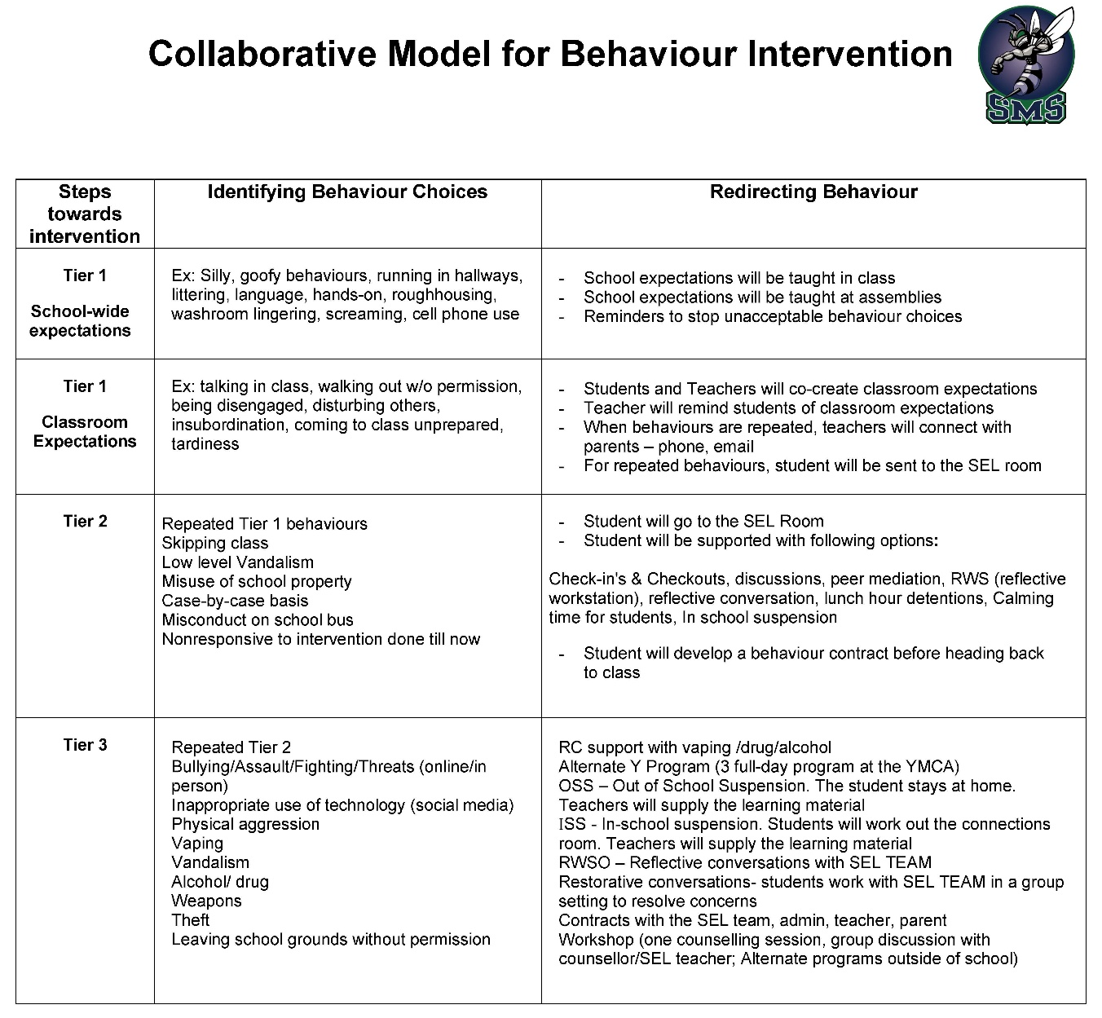

SUPPORTING STUDENT CONDUCT:
In the event of a violation of our Code of Conduct, the staff will endeavor to act consistently by:
- communicating with all individuals involved
- determining all the facts
- dealing with students with fairness and respect
We have developed a three-tiered plan (previous page) to support SMS students with their behaviour choices. Our approach is collaborative and based on the premise that "kids do well, if they can" (Dr. Ross Greene, 2005). The premise behind this quote is that students will do well if they have the skills and mindset to do so. If a student is not doing well, he/she likely has an unsolved problem or lagging skill. The school will work closely with the family to help support our students to become responsible and compassionate members of our society by developing these skills and helping to resolve problems they may be facing.

Discipline Procedures
We understand that students require assistance in their development and in subscribing to these socially responsible values and behaviours. One role of school staff is to educate and guide our learner's social development by increasing expectations and consequences as students mature both physically and socially. As a result, responses to behaviour will vary according to these variables. Generally, as a student matures, expectations will increase, and consequences will be adjusted accordingly.
We recognize that each incident must be dealt with on an individual basis, dependent upon severity, circumstance, and history. Every effort will be made to suit the consequence to the learner and the situation using a progressive disciplinary model as per district policy. Whenever possible, the learner, with the assistance of the administrator, teacher, behaviour intervention teacher, counselor, and/or parent/guardian, will be involved in solving the problem. Where appropriate, special considerations may apply to learners with special needs who violate the Code of Conduct in a manner that reflects their intellectual, physical, sensory, emotional, or behavioural abilities.
Consequences for violations of the Code of Conduct are designed to reinforce positive behaviours and encourage positive change for those involved. Consequences may include discussions and with school staff, mediation, restitution, community service, loss of personal time and/or suspension. Due to legal confidentiality reasons, school and district staff cannot disclose confidential information related to a child's disciplinary details or consequences to anyone other than the legal guardian of the child. The use of consequences will be governed by the following principles:
Consequences will:
- be appropriate to the student's stage of development
- reflect the intensity, frequency and/or duration of the inappropriate behaviour
- make sense to the student as much as possible and be appropriately time
Minor violations of the Code of Conduct are dealt with in a variety of ways, including meetings with students, school staff and parents.
For serious breaches of the Code of Conduct, suspensions from school may be issued by an administrator. A suspension is the removal of a student's right to attend regularly scheduled instructional sessions. Suspensions may either be definite or indefinite:
- Definite suspensions, whether in-school or out of school, are suspensions up to and including ten school days
- Indefinite suspensions are those in excess of ten school days and are referred to the District Suspension Review Committee
Suspensions may include one or more of the following objectives to:
- improve and/or correct student behaviour
- deter other students from similar behaviour
- plan proactive educational interventions
- clarify and solve problems
- protect the suspended student and/or other students/staff from dangerous behaviours
- provide or develop restorative justice opportunities

STUDENT APPEARANCE
Students are expected to be well groomed and wear clothing appropriate for the activities of the day. The following regulations pertain to the dress of students:
- Clothes must not present a hazard to the student or to others.
- Clothing/jewelry with references to drugs, alcohol, sex, violence, prejudice/racism or profanity is NOT permitted.
- Appropriate footwear must be worn at all times. No slippers or socks for example.
- Outside jackets are to be left in lockers. Students are encouraged to use a hoodie in class if they feel chilled.
- Please remember this is a place of work and learning. Dress accordingly!

REPORTING STUDENT PROGRESS

At Springvalley Middle School, our reporting procedures inform parents of:
- What the student is able to do in relation to the curriculum outlines
- What areas of improvement are required
- What support is available to the student to assist in achieving these goals
- Assessment summaries based on achievement of the Curricular Competencies

Students will receive three formal reporting documents. The dates for these reports will be listed on our calendar in September, but generally come just before major breaks in the school year: Winter, Spring and Summer Breaks.

Written comments are included with each report. These comments should provide you with more specific information regarding your child's progress.

Twice per year the school schedules Parent Teacher Conference days as well as Student Led Conferences. However, parents are encouraged to arrange individual or group meetings with teachers to discuss academic and/or personal issues at any time. We would like to encourage you to take advantage of three-way conferencing. This is when parents, students and teachers meet to discuss student progress and work together to develop goals for the next term. Studies show that communication between the home and school improves when parents and students are both involved in conferencing.

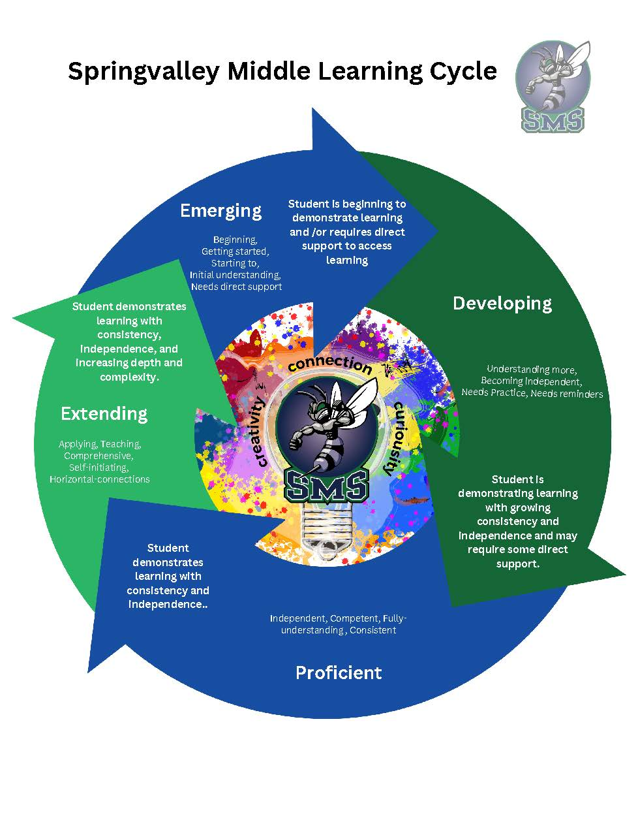

EXTRA CURRICULAR ACTIVITIES

At Springvalley Middle School, students are encouraged to become involved in a wide range of extra-curricular activities. Our staff volunteers their time to sponsor these activities and appreciate any parent support and assistance. Please encourage your child to GET INVOLVED! For information on extra-curricular athletics please contact the school Athletic Director or consult the school website sms.sd23.bc.ca and click on 'Athletics'.

HOT LUNCH & BREAKFAST FOR LEARNING

- The PAC's Hot Lunch Program is available on Mondays. Please order online at: sms.sd23.bc and click on SMS Hot Lunch Program (access code SVHL) A new account is required each year.
- Breakfast for Learning runs every morning with the help of Community Volunteers and school staff.
- Brown Bag Lunches are available for those families experiencing hardship - please contact our Aboriginal Advocate and/or Receptionist for access to this program.

PARENT ADVISORY COUNCIL

Your voice at the school level - The Parent Advisory Council (PAC) is the officially recognized voice of parents at the school level. The PAC is composed of parents who have students registered in the school. School staff may be invited to meetings. The PAC meets on a regular basis to consider school issues of concern to parents and to organize presentations and topics of interest to parents. Our PAC meetings are held monthly (September to June) beginning at 6:15 p.m. Please check the school's online calendar for specific dates.

The Purpose of the SMS Parent Advisory Council is to communicate with parents about school programs, policies and activities. The PAC has a regular system of communication, which includes a Facebook page, an information bulletin board, information e- mailings to parents, and monthly meetings, which are open to all parents.

HOW CAN YOU GET INVOLVED?

There are many opportunities for parents to become involved in the education process. At SMS PAC fundraising is an important area but certainly not the only one. Any of the following areas would benefit from increased parent involvement:

Breakfast for Learning Drivers for field trips
Hot Lunch program Planning Committees
Coaching Sports Teams PAC Executive
Assisting Sports Coaches

The Springvalley PAC is very involved in all areas of school. School leadership, staff and parents are working hard to be equal partners in the education of our children. If you have any questions, please contact the PAC by e-mailing Sms.pacpresident@sd23.bc.ca

Check out our school website at sms.sd23.bc.ca We update daily!

SPRINGVALLEY MIDDLE SCHOOL
350 Ziprick Road, Kelowna, BC V1X 4H3
Phone: 250-870-5111 Fax: 250-870-5011
sms@sd23.bc.ca
sms.sd23.bc.ca

N:\Data\Off_Data\NEW STUDENT FORMS\2024-2025 Welcome to SMS Parent Student Information Handbook DRAFT.docx

